# SPRINT 1: Classification of Arrhythmia by Using Deep Learning With 2-D ECG Spectral Image Representation

**Team ID: PNT2022TMID24237**

# Team members: Krishna Sai, Sai Kiran, Madhuri, Vignesh.K

**Code:** Updated in GitHub in the Deliverables section in Sprint1 folder.

## Description of USN and Screenshots:

**USN-1:**

As a user, I will get the full idea of ECG Arrhythmia classification using CNN where the details of the webpage will be given and info about different CVDs are provided. The homepage must properly define the Arrhythmia, its causes and effects and understand how the application helps in solving the problem.

## Screenshot:

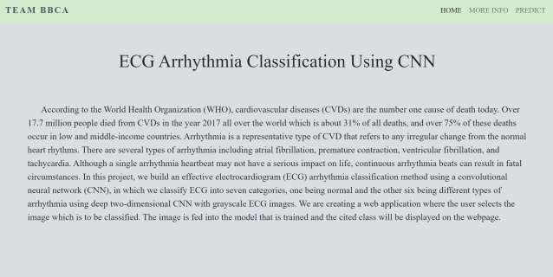

**USN-2:**

As a user, I can enter the webpage and view the homepage about the information about Electrocardiography **(ECG)** giving a clear perspective of the signals. I must also be able to comprehend all medical jargon related to Arrhythmia such as ECG, Coronary Heart Disease, Cardiomyopathy and its types.

## Screenshot

